**Web Server Hosting & Linux Essentials — Assignment**

# Intro

Deployed and secured an Ubuntu server, installed Nginx, and hosted three apps simultaneously — **WordPress (abc.com)**, **Python Flask (xyz.com)**, and **React (xyz.com/react)** — each running as services or served by Nginx. Below are the steps, exact commands to recreate each step, and placeholders for screenshots you should collect.

# 1. Server Setup & Security

**What I did (short)**

1. Confirmed Ubuntu environment.
2. Hardened SSH: disabled password login, enforced key-based auth, changed SSH port to 2222.
3. Locked inbound traffic with iptables (allow only SSH, HTTP(80), HTTPS(443)).
4. Made rules persistent.

## How to re-create (step-by-step)

**A. Verify OS / environment**

lsb_release -a

* **What:** Show Linux distro info.
* **Syntax:** lsb_release [flags]
* **Flag:** -a = all details.

cat /etc/os-release

* **What:** Show OS identification file.
* **Syntax:** cat [file]
* **Flags (optional):** -n = number lines, -b = non-blank lines.

uname -a

* **What:** Show system & kernel info.
* **Syntax:** uname [flags]
* **Flag:** -a = all, -r = release, -m = machine arch.

hostnamectl

* **What:** Show/set hostname + OS/kernel.
* **Syntax:** hostnamectl [command]
* **Flags:** status = show info, set-hostname <name> = change name.

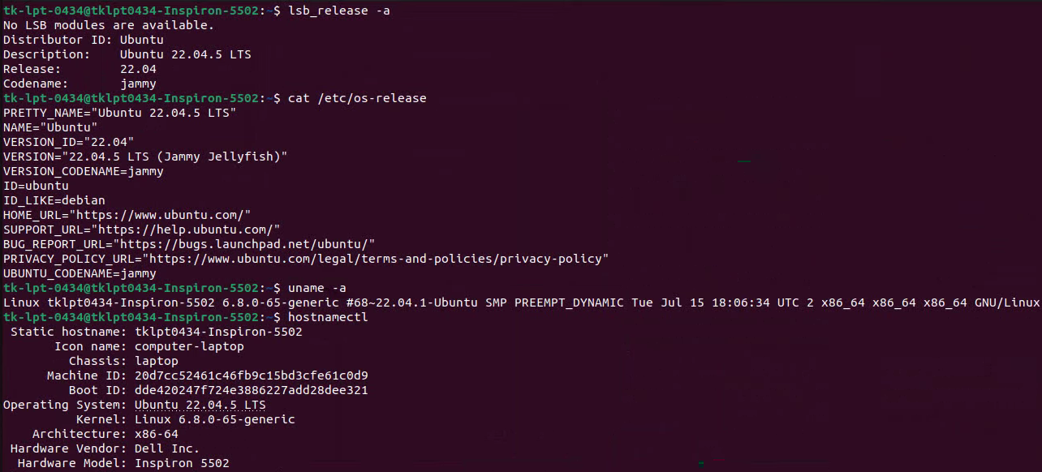

**B. Edit sshd_config to harden SSH**

sudo cp /etc/ssh/sshd_config /etc/ssh/sshd_config.bak

* **What:** Makes a backup copy of SSH config file.
* **Syntax:** cp [source] [destination]

sudo sed -i 's/#Port 22/Port 2222/' /etc/ssh/sshd_config

* **What:** Replaces #Port 22 with Port 2222 in SSH config.
* **Syntax:** sed [options] 's/find/replace/' file
* **Flag:** -i = edit file in place.

sudo sed -i 's/PasswordAuthentication yes/PasswordAuthentication no/' /etc/ssh/sshd_config

* **What:** Turns off password login in SSH config.

sudo sed -i 's/#PubkeyAuthentication yes/PubkeyAuthentication yes/' /etc/ssh/sshd_config

* **What:** Enables public key authentication in SSH config.

sudo systemctl restart ssh

* **What:** Restarts the SSH service to apply changes.
* **Syntax:** systemctl [command] [service]
* **Command:** restart = stop + start service.

sudo grep -E "Port|PasswordAuthentication|PubkeyAuthentication" /etc/ssh/sshd_config

* **What:** Searches SSH config for specific settings.
* **Syntax:** grep [options] "pattern" file
* **Flag:** -E = extended regex (allows multiple patterns with |).

sudo ss -tuln | grep 2222

* **What:** Lists listening sockets, filtered for port 2222.
* **Syntax:** ss [options]
* **Flags:**
  + -t = TCP || -u = UDP || -l = listening || -n = numeric addresses/ports.

**How it was done:** edited /etc/ssh/sshd_config to set Port 2222, PasswordAuthentication no, and enforced PubkeyAuthentication. Restarted the SSH service to apply changes.

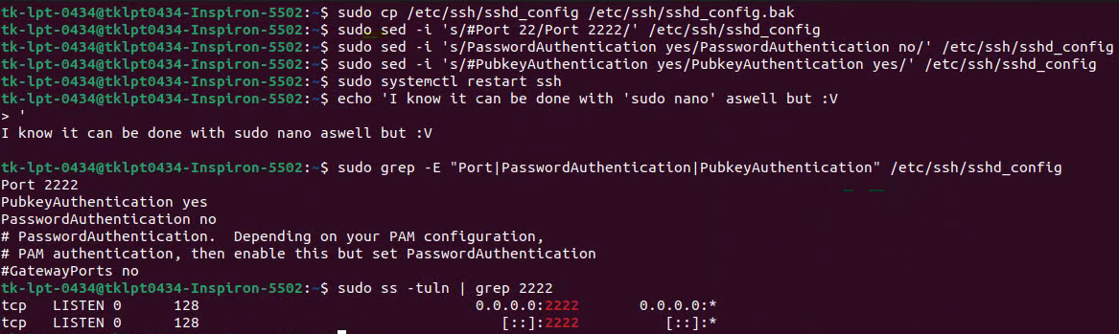

**C. Set iptables rules and save**

Allow SSH (2222), HTTP (80), HTTPS (443)

sudo iptables -F

* **What:** Flushes (clears) all firewall rules.
* **Syntax:** iptables -F [chain]
* **Flag:** -F = flush chain (default = all).

sudo iptables -A INPUT -m conntrack --ctstate RELATED,ESTABLISHED -j ACCEPT

* **What:** Allows existing/related connections.
* **Syntax:** iptables -A [chain] [options] -j [action]
* **Flags:**
  + -A = append rule.
  + -m conntrack = use connection tracking module.
  + --ctstate RELATED,ESTABLISHED = allow established traffic.
  + -j ACCEPT = accept packet.

sudo iptables -A INPUT -p tcp --dport 2222 -j ACCEPT

* **What:** Allows incoming SSH on port 2222.
* **Flags:**
  + -p tcp = protocol TCP.
  + --dport 2222 = destination port.
  + -j ACCEPT = allow traffic.

sudo iptables -A INPUT -p tcp --dport 80 -j ACCEPT

* **What:** Allows HTTP traffic.
* **Flags:** same as above, port 80.

sudo iptables -A INPUT -p tcp --dport 443 -j ACCEPT

* **What:** Allows HTTPS traffic.
* **Flags:** same as above, port 443.

sudo iptables -A INPUT -i lo -j ACCEPT

* **What:** Allows all traffic on loopback (localhost).
* **Flags:** -i lo = input interface = loopback.

sudo iptables -A INPUT -j DROP

* **What:** Drop all other incoming packets.
* **Flags:** -j DROP = deny silently.

Install persistence

sudo apt update && sudo apt install -y iptables-persistent netfilter-persistent

* **What:** Updates package index and installs persistence tools.
* **Syntax:** apt install [package]
* **Flags:** -y = auto confirm yes.
* **Packages:**

iptables-persistent = save/load rules at boot   
netfilter-persistent = backend service to manage them.

**sudo netfilter-persistent save**

* **What:** Saves current iptables rules to disk (/etc/iptables/rules.v4).
* **Syntax:** netfilter-persistent save

**How it was done:** appended explicit ACCEPT rules and a final DROP for everything else; saved rules with iptables-persistent.

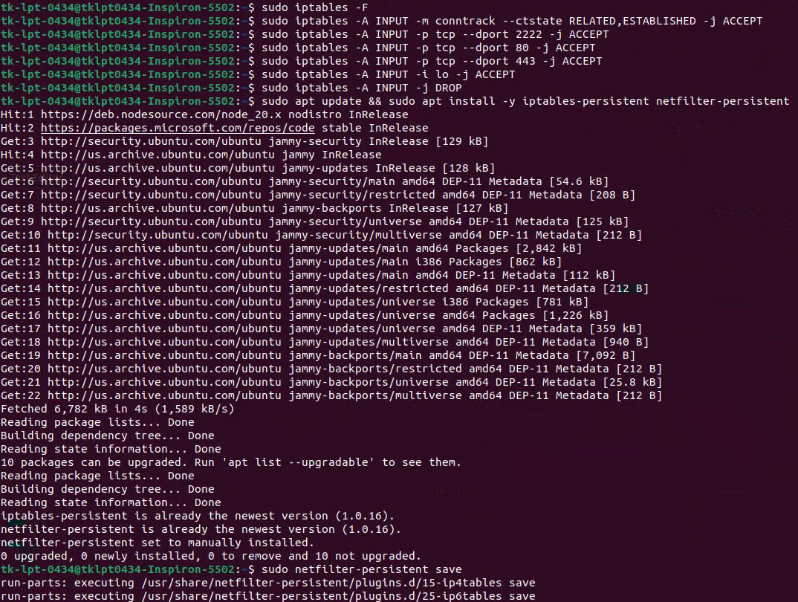

See results:

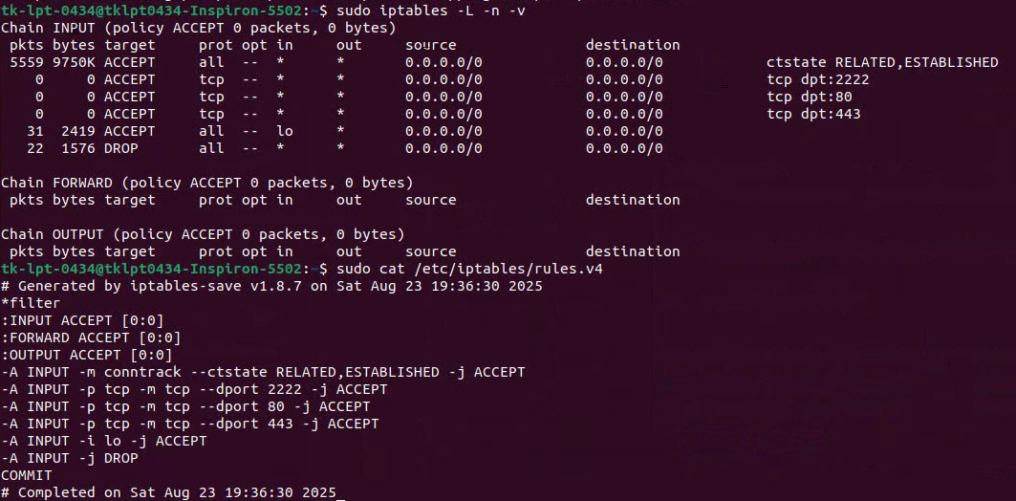

**What does this output mean?**

First commands –

sudo iptables -L -n -v

* **What:** Lists all active iptables rules.
* **Syntax:** iptables -L [chain] [options]
* **Flags:**
  + -L = list rules.
  + -n = numeric (don’t resolve hostnames).
  + -v = verbose (packet/byte counters).

sudo cat /etc/iptables/rules.v4

* **What:** Displays saved IPv4 firewall rules file.

**Output Details:**

**Header**

Chain INPUT (policy ACCEPT 0 packets, 0 bytes)

* **Chain INPUT** → Incoming traffic rules.
* **policy ACCEPT** → Default action is *accept* unless a rule matches.
* **0 packets, 0 bytes** → Since startup, no packets hit the default policy.

pkts bytes target prot opt in out source destination

* **pkts / bytes** → Counters showing how many packets/bytes matched this rule.
* **target** → What happens (ACCEPT, DROP).
* **prot** → Protocol (tcp/udp/all).
* **in/out** → Which interface (e.g., lo = loopback, * = any).
* **source/destination** → Allowed IP ranges (0.0.0.0/0 = any).

**Rules**

5559 9750K ACCEPT all -- * * 0.0.0.0/0 0.0.0.0/0 ctstate RELATED,ESTABLISHED

* **5559 packets / 9750K bytes** matched.
* **ACCEPT** → Allowed.
* **ctstate RELATED,ESTABLISHED** → This allows responses to outgoing connections (e.g., when you browse, replies can come back).

0 0 ACCEPT tcp -- * * 0.0.0.0/0 0.0.0.0/0 tcp dpt:2222

* **0 packets / 0 bytes** yet.
* Accept TCP traffic to **port 2222** (custom SSH).

0 0 ACCEPT tcp -- * * 0.0.0.0/0 0.0.0.0/0 tcp dpt:80

* Accept TCP traffic to **port 80 (HTTP)**.

0 0 ACCEPT tcp -- * * 0.0.0.0/0 0.0.0.0/0 tcp dpt:443

* Accept TCP traffic to **port 443 (HTTPS)**.

31 2419 ACCEPT all -- lo * 0.0.0.0/0 0.0.0.0/0

* **31 packets / 2419 bytes** matched.
* Accept all traffic via **loopback (lo)** (programs talking to themselves).

22 1576 DROP all -- * * 0.0.0.0/0 0.0.0.0/0

* **22 packets / 1576 bytes** dropped. Catches everything not explicitly allowed.

By reading rules.v4

This is the **saved version** of the above rules (so they persist after reboot).

*filter

:INPUT ACCEPT [0:0]

:FORWARD ACCEPT [0:0]

:OUTPUT ACCEPT [0:0]

* Defines chains (INPUT, FORWARD, OUTPUT).
* Default policy = ACCEPT.

-A INPUT -m conntrack --ctstate RELATED,ESTABLISHED -j ACCEPT

* Allow responses to outgoing connections.

-A INPUT -p tcp -m tcp --dport 2222 -j ACCEPT

* Allow SSH on port 2222.

-A INPUT -p tcp -m tcp --dport 80 -j ACCEPT

* Allow HTTP.

-A INPUT -p tcp -m tcp --dport 443 -j ACCEPT

* Allow HTTPS.

-A INPUT -i lo -j ACCEPT

* Allow localhost traffic.

-A INPUT -j DROP

* Drop everything else.

# 2. Web Server (Nginx) Installation & Basic Checks

**What I did (short)**

Installed Nginx, enabled and ran it as a systemd service.

**Commands to run**

sudo apt update

* **What:** Refreshes package index (gets latest list of available packages/versions).
* **Syntax:** apt update
* **Flags:** none (but must be run with sudo).

sudo apt install -y nginx

* **What:** Installs the Nginx web server.
* **Syntax:** apt install [options] package
* **Flags:** -y → auto-yes to prompts.

sudo systemctl enable --now nginx

* **What:** Enables Nginx to start on boot and starts it immediately.
* **Syntax:** systemctl enable [service]
* **Flags:** --now → also start service right away.

nginx -v

* **What:** Shows installed Nginx version.
* **Syntax:** nginx [flags]
* **Flags:** -v → version only. || -V → detailed build/config info.

sudo systemctl status nginx --no-pager

* **What:** Shows Nginx service status (active, PID, logs).
* **Syntax:** systemctl status [service]
* **Flags:** --no-pager → print full output without paging.

sudo ss -tuln | grep ':80\|:443'

* **What:** Checks if Nginx is listening on HTTP (80) and HTTPS (443).
* **Syntax:** ss [options]
* **Flags:**
  + -t = TCP sockets.
  + -u = UDP sockets.
  + -l = listening sockets.
  + -n = numeric (don’t resolve names).

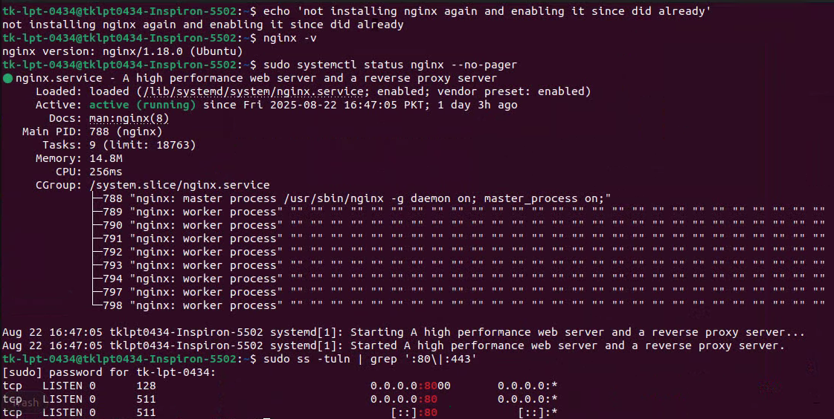

**How it was done:** apt install nginx, then systemctl enable --now nginx to auto-start on boot. Verified with nginx -v and systemctl status nginx.

## 3. Application Hosting — per app

For each app: I’ll show the exact commands used to deploy, the reason, and the commands to capture screenshots (file lists, service status, curl checks, config snippets).

### A — WordPress (abc.com)

**What I did (short)**

Downloaded WordPress, installed PHP + MySQL, configured DB and wp-config.php, set proper ownership, and served via Nginx with PHP-FPM.

**How to re-create (commands)**

**# 1) Files & ownership**

cd /var/www

* **What:** Changes current working directory to /var/www (standard web root on Linux).
* **Syntax:** cd [directory]
* **Flags:** none.

sudo wget https://wordpress.org/latest.tar.gz

* **What:** Downloads the latest WordPress archive from the official site.
* **Syntax:** wget [options] URL
* **Flags (common):**
  + none here (defaults to save file with original name).
  + -O filename = save with custom name.

sudo tar -xzvf latest.tar.gz

* **What:** Extracts the WordPress archive.
* **Syntax:** tar [options] file
* **Flags:**
  + -x = extract.
  + -z = decompress gzip.
  + -v = verbose (list files).
  + -f = filename follows.

sudo chown -R www-data:www-data wordpress

* **What:** Changes ownership of the wordpress folder to user/group www-data (the web server).
* **Syntax:** chown [options] user:group file
* **Flags:**
  + -R = recursive (apply to all subfolders/files).

sudo rm latest.tar.gz

* **What:** Deletes the downloaded archive after extraction (cleanup).
* **Syntax:** rm [options] file
* **Flags:**
  + none here.
  + -f = force (ignore errors).
  + -r = recursive (for dirs).

**# 2) PHP & MySQL**

sudo apt install -y mysql-server php-fpm php-mysql php-curl php-gd php-mbstring php-xml php-xmlrpc php-zip

* **What it does:** Installs MySQL database server + PHP runtime + required PHP extensions for WordPress.
* **Syntax:** apt install [options] package1 package2 ...
* **Flags:** -y → auto-confirm “yes” to install.

**Packages explained (one by one):**

* mysql-server → MySQL DB server.
* php-fpm → FastCGI Process Manager (runs PHP scripts for Nginx).
* php-mysql → PHP module to connect PHP with MySQL.
* php-curl → PHP module for HTTP requests (API calls).
* php-gd → PHP module for image processing.
* php-mbstring → Handles multibyte strings (UTF-8, non-English text).
* php-xml → XML handling in PHP.
* php-xmlrpc → Remote procedure calls over XML (legacy, some plugins use it).
* php-zip → Zip archive handling in PHP (import/export plugins).

In short: this one-liner sets up **everything WordPress needs**: database + PHP engine + extra modules.

**# 3) Secure MySQL and create DB/user**

sudo mysql_secure_installation

* **What:** Runs an interactive script to secure MySQL (set root password, remove test DB, disable remote root, etc.).

sudo mysql -u root -p -e "CREATE DATABASE wordpress;"

* **What:** Creates a database named wordpress.
* **Syntax:** mysql -u [user] -p -e "SQL command"
* **Flags:** -u root = login as root || -p = prompt for password || -e = execute directly

sudo mysql -u root -p -e "CREATE USER 'wpuser'@'localhost' IDENTIFIED BY 'securepassword';"

* **What:** Creates a MySQL user wpuser with password securepassword, allowed only from localhost.
* **Same syntax/flags as above.**

**NOTE:** I created another user called ‘admin’ with the same password. This command is just an example

sudo mysql -u root -p -e "GRANT ALL PRIVILEGES ON wordpress.* TO 'wpuser'@'localhost'; FLUSH PRIVILEGES;"

* **What:** Grants full permissions on the wordpress DB to wpuser, then applies changes with FLUSH PRIVILEGES;.
* **Same syntax/flags as above.**

In short:

1. Secure MySQL.
2. Make a DB for WordPress.
3. Make a DB user.
4. Give that user full rights on the DB.

**wp-config creation / placeholder injection**

cd /var/www/wordpress

* **What:** Change directory into the WordPress installation folder.
* **Syntax:** cd [directory_path]
* **Flags:** none.

sudo cp wp-config-sample.php wp-config.php

* **What:** Copy the default sample configuration file to a new working config file.
* **Syntax:** cp [options] source destination
* **Flags:** -i = prompt before overwrite || -r = recursive (for directories).  
  *(none used here)*

sudo sed -i "s/database_name_here/wordpress/" wp-config.php

* **What:** Replace database_name_here with wordpress inside the config file.
* **Syntax:** sed [options] 's/pattern/replacement/' file
* **Flags:** -i = edit file in place || s/// = substitute text.

sudo sed -i "s/username_here/wpuser/" wp-config.php

* **What:** Replace username_here with wpuser in the config file.
* **Syntax/flags:** same as above.

**sudo sed -i "s/password_here/securepassword/" wp-config.php**

* **What:** Replace password_here with securepassword in the config file.
* **Syntax/flags:** same as above.

**Screenshots**

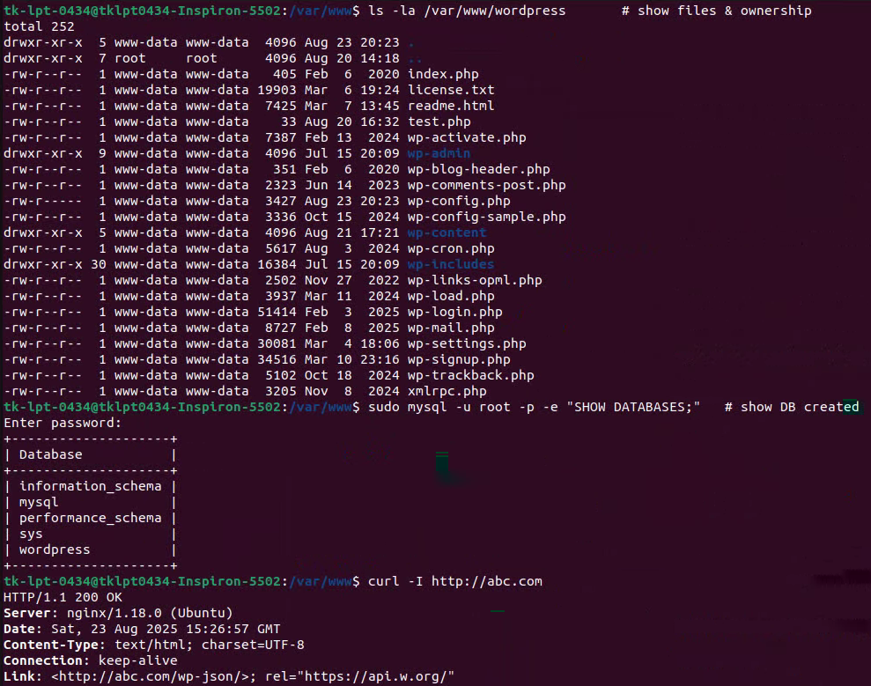

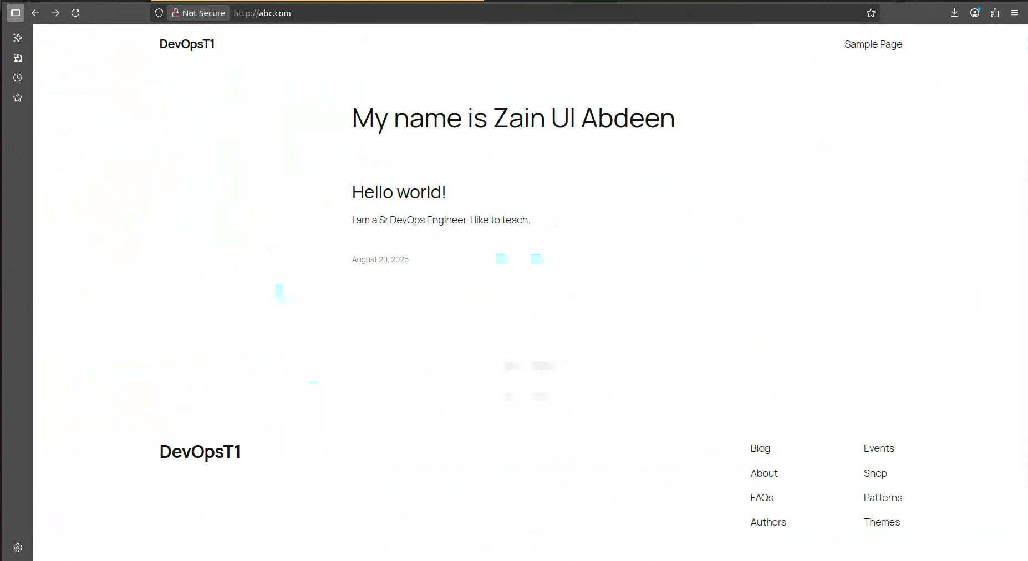

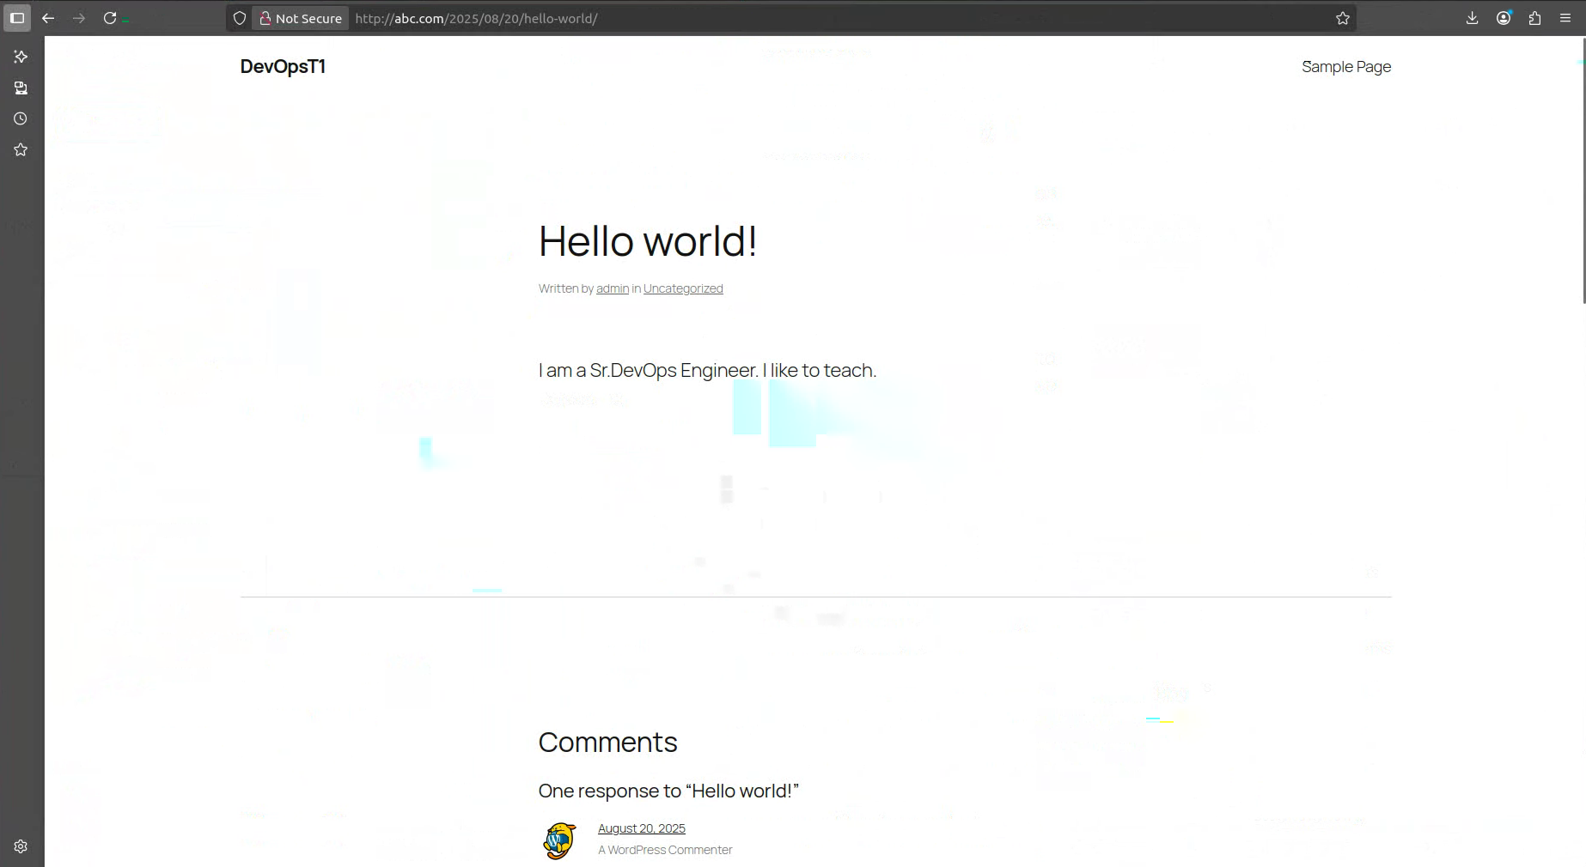

**B — Python Flask App (xyz.com)**

**What I did (short)**

Created a Flask app (number guess game), isolated it with venv, created a systemd unit to run it as a service, and proxied it with Nginx (port 6969).

**How to re-create (commands)**

sudo mkdir -p /var/www/pythonapp

* **What:** Creates the directory /var/www/pythonapp.
* **Syntax:** mkdir [options] directory_name
* **Flags:** -p = create parent directories if they don’t exist.

sudo chown -R $USER:$USER /var/www/pythonapp

* **What:** Changes ownership of the directory to your current user (from $USER env variable).
* **Syntax:** chown [options] user:group file/dir
* **Flags:** -R = recursive, apply to all inside files/folders.

cd /var/www/pythonapp

* **What:** Change into the Python app directory.
* **Syntax:** cd [path]

**Virtual Environment + Flask Setup**

python3 -m venv venv

* **What:** Creates a Python virtual environment named venv inside the current directory.
* **Syntax:** python3 -m venv [directory_name]

source venv/bin/activate

* **What:** Activates the virtual environment so Python/pip use isolated packages.
* **Syntax:** source [script]

pip install flask

* **What:** Installs Flask framework inside the venv.
* **Syntax:** pip install [package]

deactivate

* **What:** Exits the virtual environment, returning to the global Python environment.

**Application Code**

**nano /var/www/pythonapp/app.py**

* **What:** Opens the file app.py for editing to paste in the Flask app code   
  (i.e i GPT-ed a code for a number guessing game, etc.).

**Systemd Service Creation**

sudo tee /etc/systemd/system/pythonapp.service > /dev/null <<'EOF' ... EOF

* **What:** Creates a new service file pythonapp.service under systemd using a here-document (EOF).
* **Syntax:** tee [file]
* **Flags:** > /dev/null = suppress output.

**[Unit]**: Description, dependency on network.

**[Service]**: Runs app as www-data, sets working dir, environment path, start command, restart policy.

**[Install]**: Ensures it runs in multi-user mode (normal boot).

[Unit]

Description=Python Flask App

After=network.target

[Service]

User=www-data

Group=www-data

WorkingDirectory=/var/www/pythonapp

Environment="PATH=/var/www/pythonapp/venv/bin"

ExecStart=/var/www/pythonapp/venv/bin/python /var/www/pythonapp/app.py

Restart=always

[Install]

WantedBy=multi-user.target

**sudo systemctl daemon-reload**

* **What:** Reloads systemd manager config so it recognizes the new service.
* **Syntax:** systemctl daemon-reload

**sudo systemctl enable --now pythonapp**

* **What:** Enables the service to auto-start on boot and starts it immediately.
* **Syntax:** systemctl enable [service]
* **Flags:** --now = enable and start instantly.

**Screenshot**

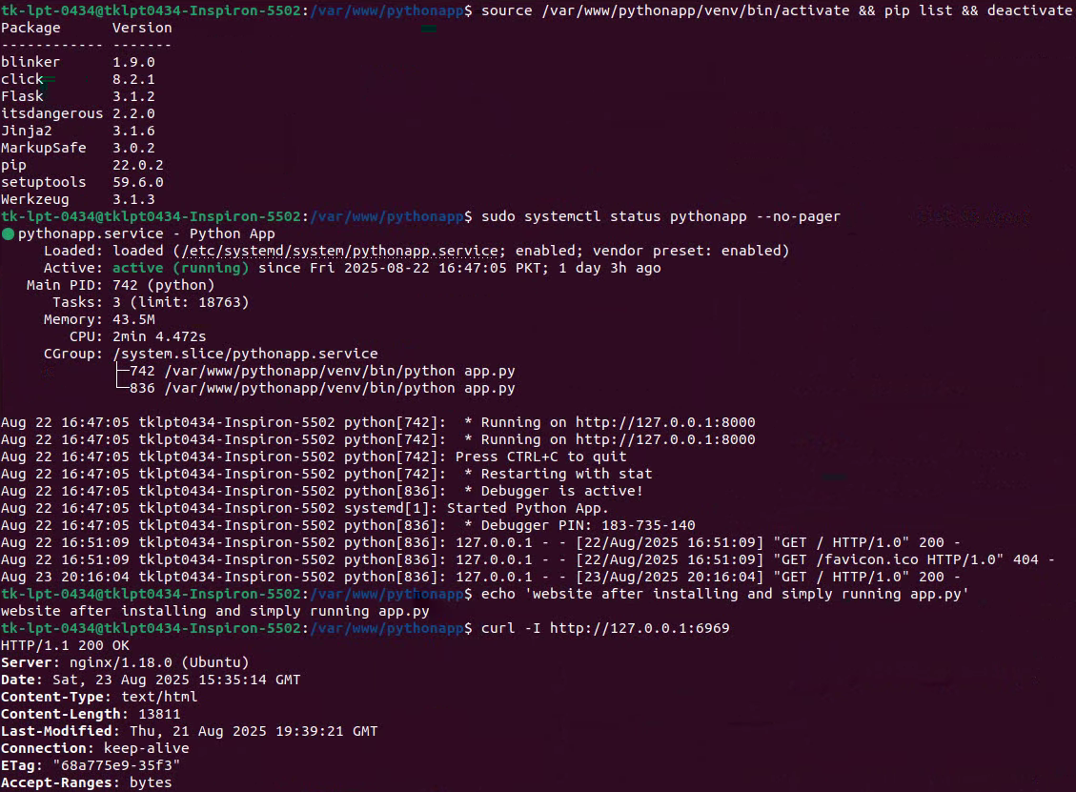 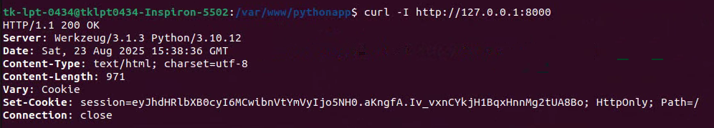

Website

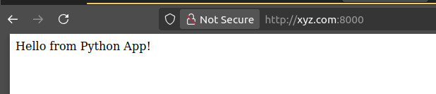

After updating with GPT-ed code



**C — React (Vite) static site (xyz.com/react)**

**What I did (short)**

Scaffolded with Vite, set base to /react/, built static files into dist/, and served via Nginx location /react.

**How to re-create (commands)**

sudo mkdir -p /var/www/reactapp

* **What:** Create a directory for the React app.
* **Syntax:** mkdir [-p] [path]
* **Flag:** -p = create parent directories if they don’t exist (avoids errors).

sudo chown -R $USER:$USER /var/www/reactapp

* **What:** Give ownership of the directory to your current user.
* **Syntax:** chown [-R] [owner:group] [path]
* **Flag:** -R = recursive (apply to all subfolders/files).

cd /var/www/reactapp

* **What:** Navigate into the app folder.
* **Syntax:** cd [directory]

curl -fsSL https://deb.nodesource.com/setup_20.x | sudo -E bash -

* **What:** Download & run Node.js 20.x setup script.
* **Syntax:** curl [options] [URL]
* **Flags:**
  + -f = fail silently on errors.
  + -s = silent (no progress bar).
  + -S = show errors.
  + -L = follow redirects.
  + | sudo -E bash - = pipe script into bash with preserved environment (-E).

sudo apt install -y nodejs

* **What:** Install Node.js (includes npm).
* **Syntax:** apt install [-y] [package]
* **Flag:** -y = assume “yes” to all prompts.

npm create vite@latest . -- --template react

* **What:** Scaffold a new React app using Vite into the current folder (.).
* **Syntax:** npm create [package] [dir] -- [options]
* **Flags:**
  + --template react = use React starter template.
  + . = install in current directory.

npm install

* **What:** Install dependencies listed in package.json.
* **Syntax:** npm install [package]
* **No flags:** installs everything needed for the project.

***(manual step)* Edit vite.config.js**

* Add base: '/react/' so app works from a subpath instead of root.

npm run build

* **What:** Compile React app into production-ready static files.
* **Syntax:** npm run [script]
* **Here:** runs "build" script defined in package.json (outputs to dist/).

sudo chown -R www-data:www-data /var/www/reactapp/dist

* **What:** Give ownership of build files to Nginx’s user (www-data).
* **Syntax:** chown [-R] [owner:group] [path]
* **Flag:** -R = recursive.

sudo chmod -R 755 /var/www/reactapp/dist

* **What:** Set permissions → owner = read/write/execute, group & others = read/execute.
* **Syntax:** chmod [-R] [mode] [path]
* **Flag:** -R = recursive.
* **Mode 755:**
  + 7 (owner) = rwx.
  + 5 (group) = r-x.
  + 5 (others) = r-x.

**Screenshots**

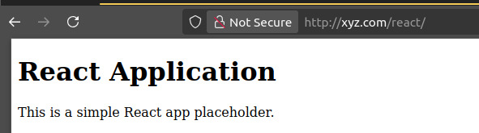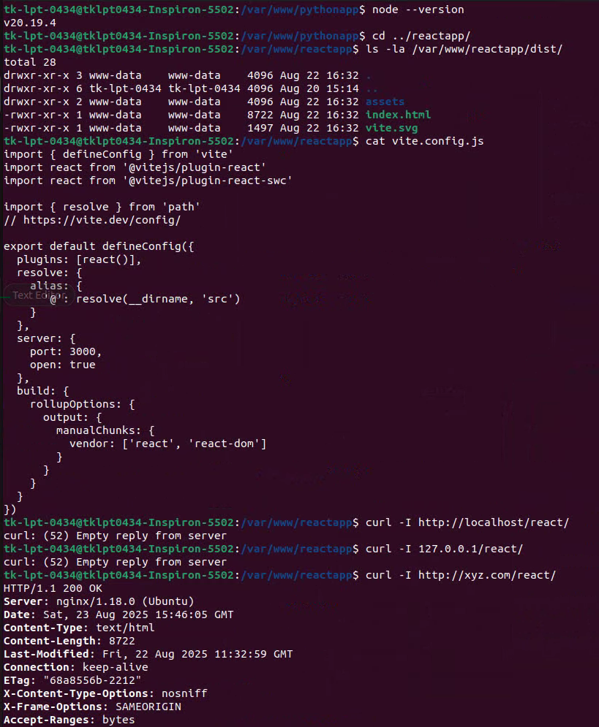

After GPT-ing the code:  
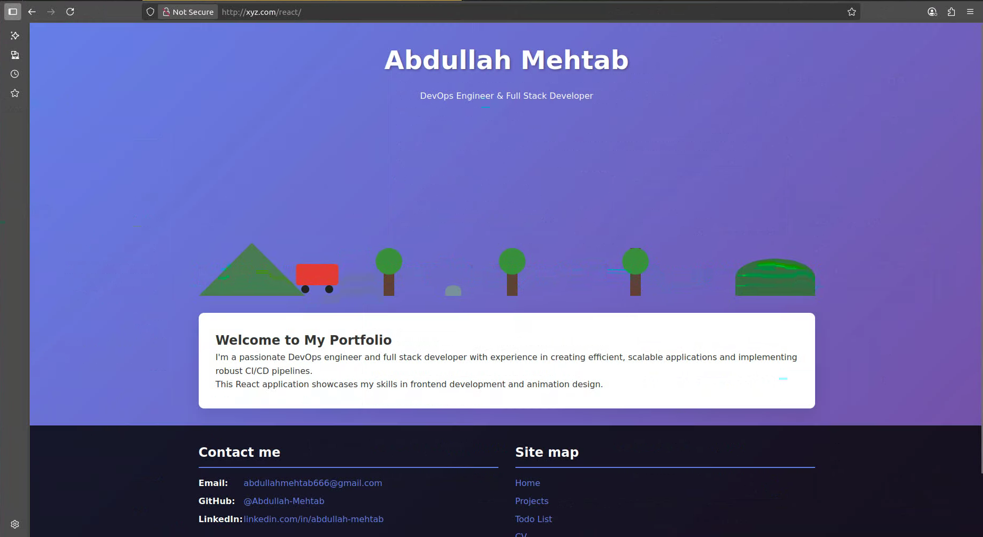

### Nginx Virtual Hosts & Routing

**What I did (short)**

Created two server blocks: abc.com (WordPress via PHP-FPM) and xyz.com (proxy to Flask + serve React at /react). Symlinked to sites-enabled, tested nginx -t, reloaded service.

**Commands + recreate steps**

**Create site config for abc.com**

**Command:**

sudo nano /etc/nginx/sites-available/abc.com

**Inside abc.com config:**

server {

listen 80;

server_name abc.com;

root /var/www/wordpress;

index index.php index.html;

location / {

try_files $uri $uri/ /index.php?$args;

}

location ~ \.php$ {

include snippets/fastcgi-php.conf;

fastcgi_pass unix:/run/php/php-fpm.sock;

}

}

**Explanation:**

* server { ... } → Defines a virtual host.
* listen 80; → Serve on HTTP port 80.
* server_name abc.com; → Respond only for requests to abc.com.
* root /var/www/wordpress; → Set web root folder.
* index index.php index.html; → Default file order if only a directory requested.

**Locations:**

* location / { ... } → Root path handling.
  + try_files $uri $uri/ /index.php?$args;
    - Check if the file exists. If not, check for folder.
    - If not, forward request to index.php with query string. (Needed for WordPress routing).
* location ~ \.php$ { ... } → Handle PHP files.
  + ~ \.php$ = regex match PHP extensions.
  + include snippets/fastcgi-php.conf; → Use standard PHP-FPM settings.
  + fastcgi_pass unix:/run/php/php-fpm.sock; → Send PHP requests to PHP-FPM (via socket).

**Create site config for xyz.com**

**Command:**

sudo nano /etc/nginx/sites-available/xyz.com

**Inside xyz.com config:**

server {

listen 80;

server_name xyz.com;

location / {

proxy_pass http://127.0.0.1:6969;

proxy_set_header Host $host;

proxy_set_header X-Real-IP $remote_addr;

}

location /react/ {

alias /var/www/reactapp/dist/;

try_files $uri $uri/ /react/index.html;

}

}

**Explanation:**

* listen 80; → Listen on HTTP port 80.
* server_name xyz.com; → Respond to requests for xyz.com.

**Locations:**

* location / { ... } → All requests to / (root) get proxied to Flask app:
  + proxy_pass http://127.0.0.1:6969; → Forward to Flask backend.
  + proxy_set_header Host $host; → Preserve original host header.
  + proxy_set_header X-Real-IP $remote_addr; → Forward client’s IP.
* location /react/ { ... } → Serve the React frontend:
  + alias /var/www/reactapp/dist/; → Map /react/ to build folder.
  + try_files $uri $uri/ /react/index.html; → Serve actual file if exists, otherwise fallback to React’s index.html (SPA routing).

**Enable the sites**

sudo ln -sf /etc/nginx/sites-available/xyz.com /etc/nginx/sites-enabled/xyz.com

* **What:** Create symlinks from sites-available to sites-enabled so Nginx loads them.
* **Flags:** -s = symbolic link || -f = force overwrite if already exists.

**Test and reload Nginx**

sudo nginx -t

* **What:** Test config for syntax errors.

sudo systemctl reload nginx

* **What:** Reload Nginx with new configs.

**The global Nginx config (main nginx.conf)**

Even though not shown, the **default nginx.conf** typically has:

* user www-data; → Run as www-data user.
* worker_processes auto; → One worker per CPU core.
* http { ... } → HTTP block with defaults.
* include /etc/nginx/sites-enabled/*; → Load all enabled site configs (like xyz.com).

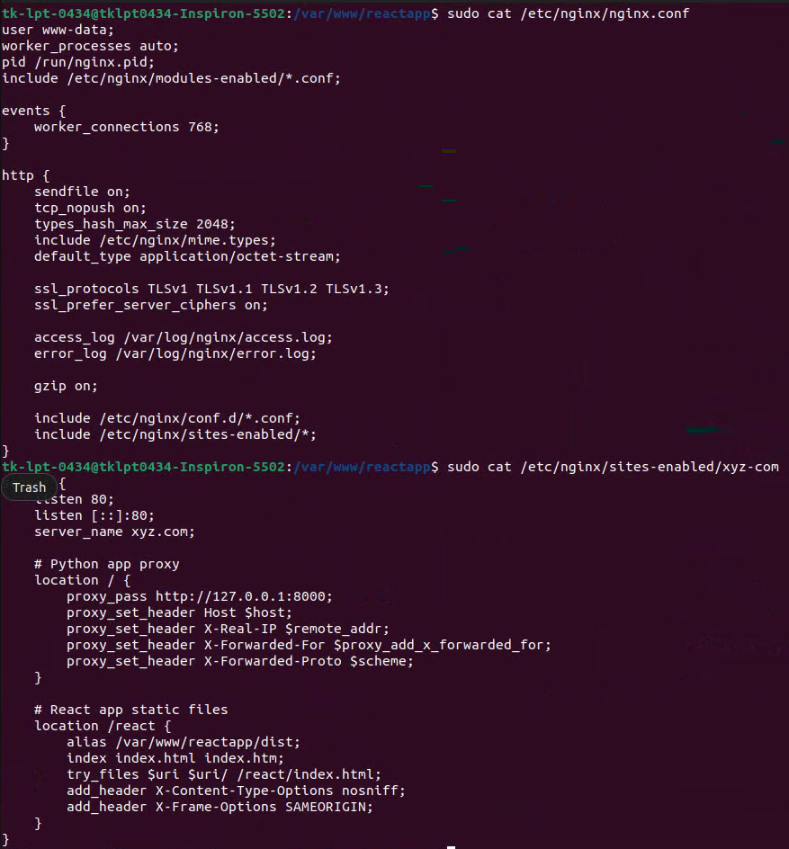

NOTE: abc-com was disabled because just use /etc/hosts to point wordpress towards abc.com

That way wordpress wont break and we dont have to define abc.com at all which is what i did later.

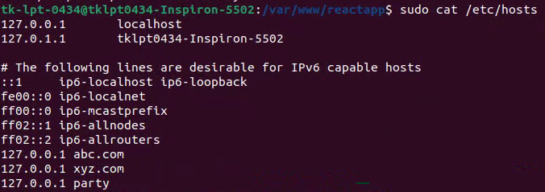

In summary:

* **abc.com** → WordPress site served from /var/www/wordpress with PHP-FPM.
* **xyz.com** → Flask backend (proxied) + React frontend (static files).
* **nginx.conf** → Pulls these configs in via sites-enabled/.
* **I also have another website at party:6969 i setup just to test**

All working at the same time

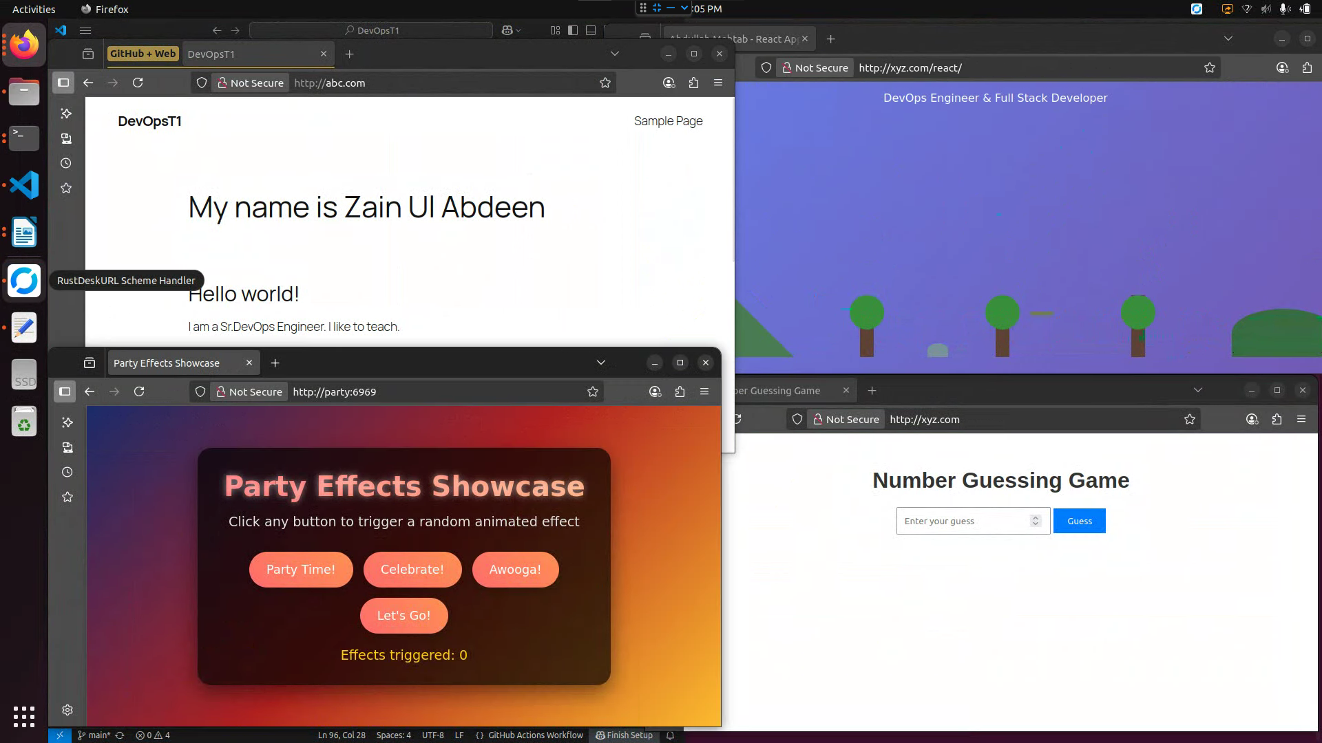

**5. CI/CD (brief — since I implemented it)**

**What I did (short)**

Used **GitHub Actions** with a **self-hosted runner** to implement CI and CD for each app (CI builds/tests → creates artifact → CD downloads artifact and deploys).

**Screenshot proof:**

**Testing by updating each application and checking if CI CD piplines work or not**

**First**

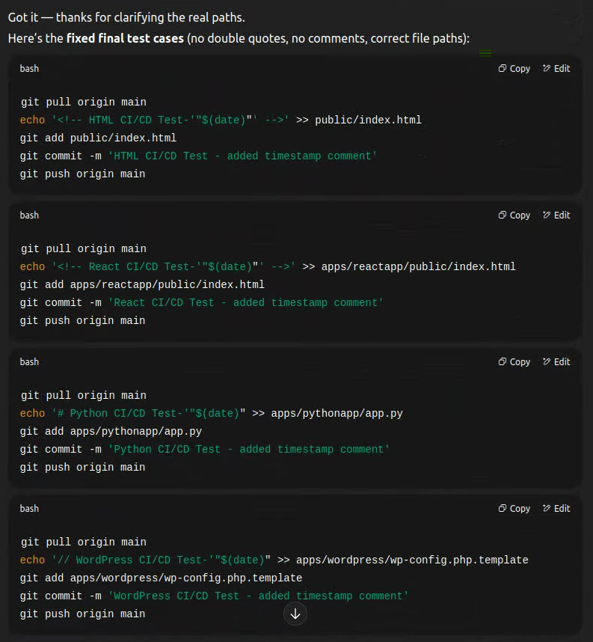

**Then**

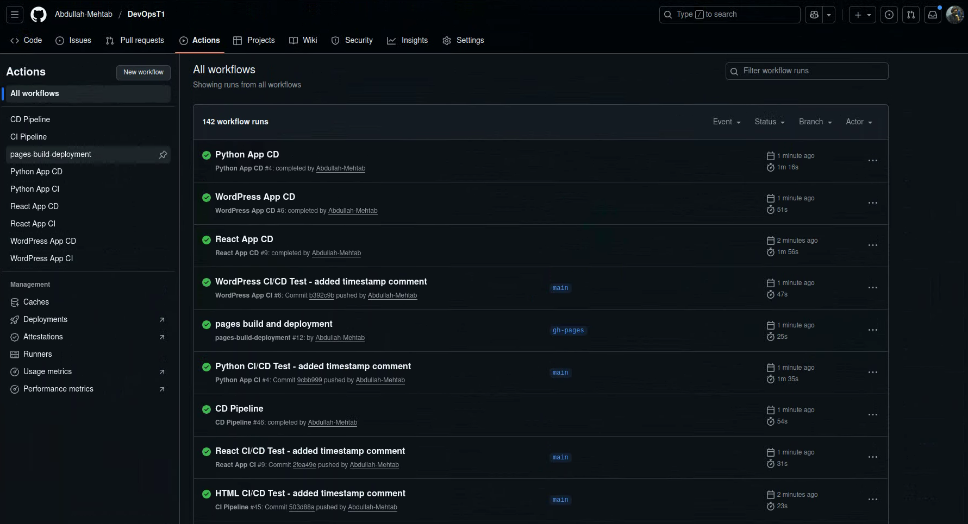

**6. Linux Command Exercises (for the assignment)**

**What I did (short)**

Created logs.txt and executed grep/awk/wc/ps/ss/ping commands to show basic Linux proficiency.

**Steps**

mkdir -p /home/$USER/intern_assignment

* **What:** Create the directory; also creates missing parent directories.
* **Syntax:** mkdir [options] directory_path
* **Flags:** -p create parents as needed (no error if exists).

cd /home/$USER/intern_assignment

* **What:** Change current working directory.
* **Syntax:** cd [directory_path]
* **Flags:** none.

cat > logs.txt <<'EOF' ... EOF

* **What:** Write the here-document contents to logs.txt (given by Zain :v)

grep "error" logs.txt

* **What:** Print lines in logs.txt containing the exact string error.
* **Syntax:** grep [options] pattern [file...]
* **Flags (common):** -i ignore case, -n show line numbers, -E extended regex (not used here).

grep -c "info" logs.txt

* **What:** Count how many lines match info.
* **Syntax:** grep -c pattern file
* **Flags:** -c output count only.

awk '{print $2}' logs.txt

* **What:** Print the second whitespace-separated field from each line.
* **Syntax:** awk 'program' file
* **Details:** $2 = second field; fields split by whitespace by default. Change with -F.

wc -l logs.txt

* **What:** Count the number of lines in the file.
* **Syntax:** wc [options] file
* **Flags:** -l lines (others: -w words, -c bytes).

ps aux | grep nginx

* **What:** List all processes, then filter lines containing nginx.
* **Syntax:**
  + ps aux = show processes for all users (a), include processes without TTY (x), user-oriented format (u).
  + | pipe: send ps output to grep.
  + grep nginx = match lines with nginx.
* **Flags:** as above; grep -v grep can be added to hide the grep process itself.

ps aux | awk '$1=="root"{count++} END {print count}'

* **What:** Count how many processes are owned by root.
* **Syntax:** ps aux | awk 'condition{action} END{final_action}'
* **Details:** In ps aux output, column 1 is the user. For each line with $1=="root", increment count; print total at end.

hostname -I

* **What:** Show all assigned IP addresses (space-separated) on the host.
* **Syntax:** hostname -I
* **Flags:** -I (capital i) = IP addresses only.

ip -4 addr show

* **What:** Show IPv4 addresses on all interfaces.
* **Syntax:** ip [-4|-6] addr show [dev IFACE]
* **Flags:** -4 IPv4 only (-6 for IPv6). addr show lists addresses.

ss -tuln

* **What:** List listening sockets (TCP/UDP) without DNS/service name lookups.
* **Syntax:** ss [options]
* **Flags:** -t TCP, -u UDP, -l listening only, -n numeric (don’t resolve names).

ping -c 4 google.com > ping_result.txt

* **What:** Send 4 ICMP echo requests to google.com and save output to a file.
* **Syntax:** ping [options] host
* **Flags:** -c 4 send 4 pings.
* **Redirection:** > write/overwrite ping_result.txt (use >> to append).

**Screenshots**

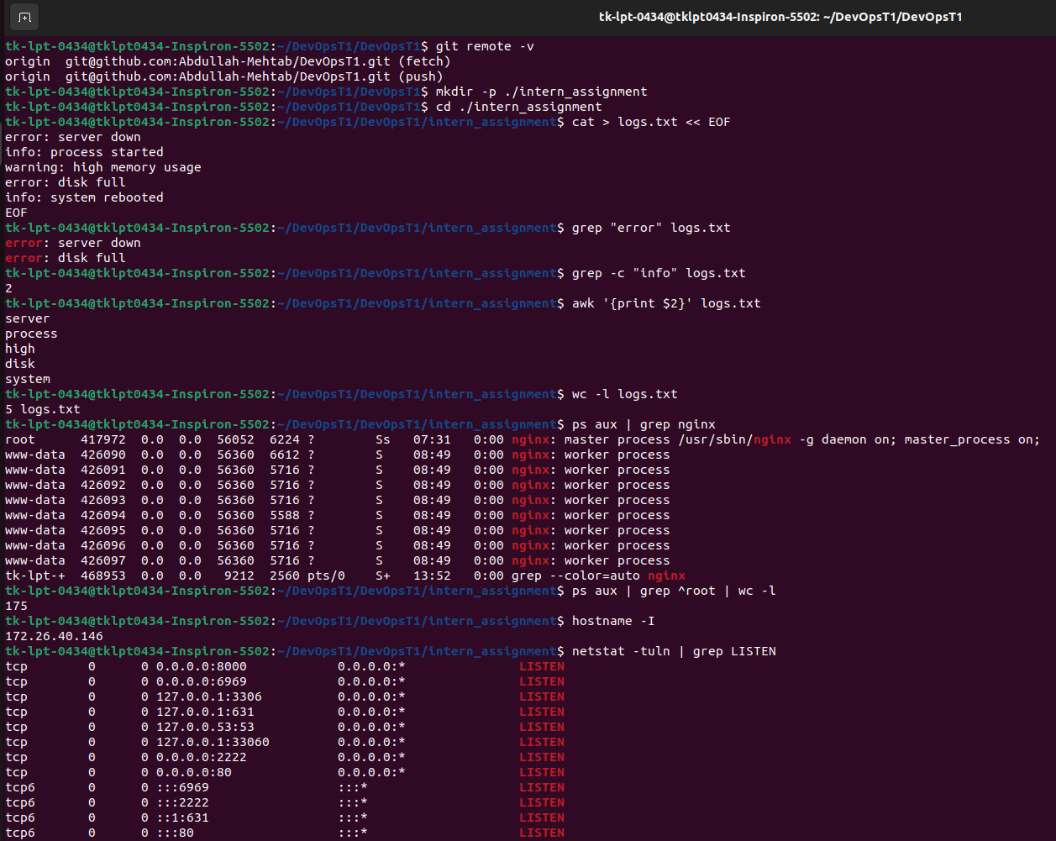

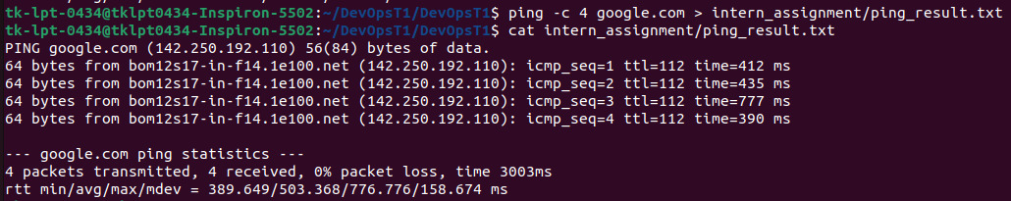

**Attached files just in case.**

**system_details.txt**: A detailed system configuration report showing the OS, running services (like Nginx, MySQL), installed applications (PHP, Python, React), and web server setup.

**ping_result.txt**: The output of a network test (ping) to google.com, showing the connection was successful with response times and no packet loss.

**command_report.txt**: A tutorial document that explains common Linux commands used for text processing, system monitoring, and networking, showing their syntax and purpose.

For the complete repo – <https://github.com/Abdullah-Mehtab/DevOpsT1/tree/main/intern_assignment>